YORK UNIVERSITY EECS 2311

Param Balaganeshan Bryan Barcos and Dhruv Patel

TalkBox Configuration App User Manual (Version 1.0)

***Introduction***

This manual describes how to navigate and use the TalkBox Configuration App that will be used to set up the client’s TalkBox by describing the major use cases.

***Installation and How to Get Started***

Once the USB that contains the system is obtained, the user will select the directory that is called “TalkBox-Pro”. Once you are this directory, there is a JAR file called TalkBox. Then download this JAR file by copying it to a local destination chosen by the user. Then once the file is copied and on the client’s system, double click on the JAR file and the application will appear.

The appearance of the TalkBox Configuration App is as follows…

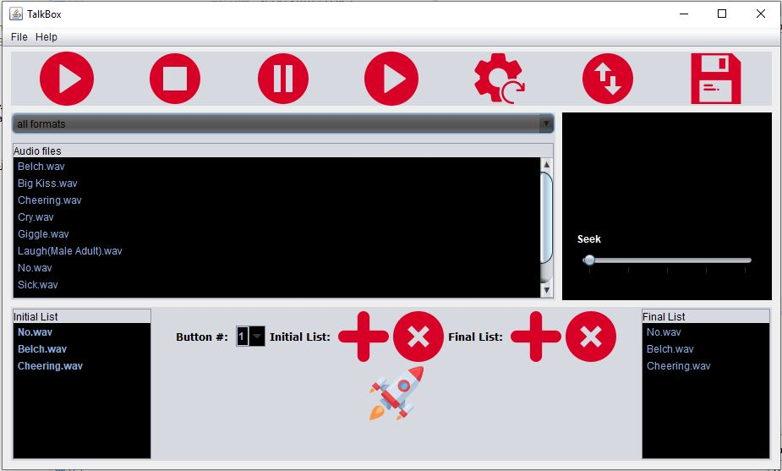

This manual is split into 3 sections…

1. ***Display Boxes***
2. ***Top Tool Bar (buttons on the top of the configuration)***
3. ***Configuration Buttons (located between the initial list and final list)***

The following will contain the necessary details to allow the client to set up the TalkBox using this app.

***Important:******The following screenshots will contain a yellow box around a component of the configuration App to highlight the component being described. Description of the highlighted area will appear before the screen shot.***

***Display Boxes of the TalkBox***

1. The following highlighted area displays the audio files the client will be able to select to configure the TalkBox. There is a scroll button to the right of the panel to access files client may not see.



1. This drop box allows the client to observe audio files with a certain extension (ex. Wav, mp3 …). Outputted files is displayed in the audio files list (refer to description 1.)



1. This box describes the initial list of the TalkBox configuration. The initial list is describing the last saved configuration the client decided to use (more on saving later in the manual). The list also describes how the audio files associate with the TalkBox buttons. The order of the buttons starts from the top (in this example, No.wav was on the first button, Belch.wav was on the second button and Cheering was on the third button).



1. Similar to the initial list, the final list describes the audio files that will be saved and outputted to the TalkBox. Association of buttons and audio files is the same for initial list (refer to description 3.) How you will configure the final list is explained in Configuration Buttons section.



***Top Toolbar of the TalkBox***

1. This button will play a sound on the selected audio on the audio files list (refer to description 1.) This simply allows the user to identity what the audio is or what it sounds like.



1. This button will stop playing the sound immediately if a sound is currently being played.



1. If a sound is being played, this button will pause the audio, if the client would like to hear the rest of the audio, refer to description 8.



1. If a sound is currently paused, this button will resume to play the audio file.



1. If the configuration needs to be completely changed or the user wants to start over in configuring the TalkBox, this button will reset the Final List (refer to description 4.). The final list will become empty.



1. This button will swap between the audio files in chronological order that is displayed on the audio file list and will swap through the list in accordance to the size of the final list.



1. This button will save the final list displayed. If any changes are made, the user will need to press the save button again before transferring the data onto the TalkBox.



***Configuration Buttons***

This is the buttons required to change the final list. Recall, the final list order is associated with the buttons in a way such that the top audio file will be placed in the first button of the TalkBox, the second file from the top will be placed in the second button and etc. The ordering of buttons goes from left to right.

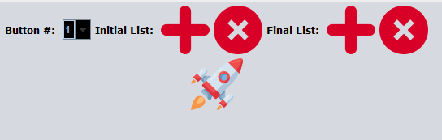

1. This button simply allocates space for more audio files in the final list. User may observe that the initial list also changes but that is not important. If you want to add more audio files, the user must allocate space first. Max number of space that can be allocated is 10 audio files.



1. This button deletes space in the Final List. User may observe that the initial list also changes but that is not important. Cannot delete further if number of buttons reaches 3.



1. **Important**, this drop menu is crucial for the configuration of the TalkBox for adding or deleting items on the final list. For deleting an audio file, when you select a number, n, this will delete the nth element of the Final List (ex. If 1 is selected, then No.wav will be deleted in reference to the screenshots shown). For adding an audio final, the number chosen, n, will place that audio file (from the audio display) in position n. The delete and add audio files button will be explained in descriptions 15. and 16.).



1. This button will allow the user to add the specified audio button from the audio files list (refer to description 1.) that does not exist in the final list and then use the Button #: drop menu (refer to description 14.) to select where to place the audio file. Then press highlighted button.
2. This button will remove the nth audio from the final list where n is selected from the Button #: drop menu (refer to description 14.).



1. Finally once the Final List is constructed, press the save button (description 11.). To observe the configuration of the clients TalkBox, the rocket button will produce a Simulator App that will resemble a TalkBox



An application like this will appear.

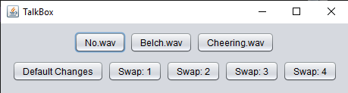

***Important: To save the Final List, the size of the Final List should be the same size user allocated (can check size using Button #: drop menu).***